BANK OF SOMEWHERE Letterhead

Date
From: Name, Title
Subject: Financial Services Sector Essential Critical Infrastructure Workers

As the Nation comes together to slow the spread of COVID-19, on March 16th, the President issued updated Coronavirus Guidance for America. This guidance states that:

“If you work in a critical infrastructure industry, as defined by the Department of Homeland Security, such as healthcare services and pharmaceutical and food supply, you have a special responsibility to maintain your normal work schedule.”

The Financial Services sector is identified as a Critical Infrastructure Sector by the Department of Homeland Security (DHS). The attached DHS guidance, issued March 19, 2020, identifies the essential critical infrastructure workers during the COVID-19 response emergency.

Within the Financial Services sector, employees deemed Essential Critical Infrastructure Workers include the following:
- Workers who are needed to process and maintain systems for processing financial transactions and services (e.g., payment, clearing, and settlement; wholesale funding; insurance services; and capital markets activities);
- Workers who are needed to provide consumer access to banking and lending services, including ATMs, and to move currency and payments (e.g., armored cash carriers); and
- Workers who support financial operations, such as those staffing data and security operations centers.

The Department of Treasury has issued guidance dated March 22, 2020 and March 24, 2020 (attached), indicating that companies aligned to the essential critical infrastructure worker definition are expected to maintain their operations and work schedules.

“…The guidance provides information to State and local officials, as they work to protect their communities, to ensure the continuity of functions that are critical to public health and safety, as well as economic and national security. …The American people need access to financial sector services, and State and local governments must ensure the continuity of critical financial sector functions. …”

Pursuant to the guidance above, Name is considered an Essential Critical Infrastructure Worker as her/his job duties are needed to [include bulleted information above, as applicable].

Should you have questions or concerns about this determination, contact Name, Title at 888-888-8888.
Should you have questions about the list of Essential Critical Infrastructure Workers, please contact CISA at CISA.CAT@cisa.dhs.gov.

Name
Title
Contact Information

GUIDANCE ON THE ESSENTIAL CRITICAL INFRASTRUCTURE WORKFORCE
March 19, 2020
Read the Guidance on the Essential Critical Infrastructure Workforce

MEMORANDUM ON IDENTIFICATION OF ESSENTIAL CRITICAL INFRASTRUCTURE WORKERS DURING COVID-19 RESPONSE

FROM: Christopher C. Krebs
Director
Cybersecurity and Infrastructure Security Agency (CISA)

As the Nation comes together to slow the spread of COVID-19, on March 16th, the President issued updated Coronavirus Guidance for America. This guidance states that:
“If you work in a critical infrastructure industry, as defined by the Department of Homeland Security, such as healthcare services and pharmaceutical and food supply, you have a special responsibility to maintain your normal work schedule.”
The Cybersecurity and Infrastructure Security Agency (CISA) executes the Secretary of Homeland Security’s responsibilities as assigned under the Homeland Security Act of 2002 to provide strategic guidance, promote a national unity of effort, and coordinate the overall federal effort to ensure the security and resilience of the Nation's critical infrastructure. CISA uses trusted partnerships with both the public and private sectors to deliver infrastructure resilience assistance and guidance to a broad range of partners.
In accordance with this mandate, and in collaboration with other federal agencies and the private sector, CISA developed an initial list of “Essential Critical Infrastructure Workers” to help State and local officials as they work to protect their communities, while ensuring continuity of functions critical to public health and safety, as well as economic and national security. The list can also inform critical infrastructure community decision-making to determine the sectors, sub-sectors, segments, or critical functions that should continue normal operations, appropriately modified to account for Centers for Disease Control (CDC) workforce and customer protection guidance.
The attached list identifies workers who conduct a range of operations and services that are essential to continued critical infrastructure viability, including staffing operations centers, maintaining and repairing critical infrastructure, operating call centers, working construction, and performing management functions, among others. The industries they support represent, but are not necessarily limited to, medical and healthcare, telecommunications, information technology systems, defense, food and agriculture, transportation and logistics, energy, water and wastewater, law enforcement, and public works.
We recognize that State, local, tribal, and territorial governments are ultimately in charge of implementing and executing response activities in communities under their jurisdiction, while the Federal Government is in a supporting role. As State and local communities consider
COVID-19-related restrictions, CISA is offering this list to assist prioritizing activities related to continuity of operations and incident response, including the appropriate movement of critical infrastructure workers within and between jurisdictions.
Accordingly, this list is advisory in nature. It is not, nor should it be considered to be, a federal directive or standard in and of itself.
In addition, these identified sectors and workers are not intended to be the authoritative or exhaustive list of critical infrastructure sectors and functions that should continue during the COVID-19 response. Instead, State and local officials should use their own judgment in using their authorities and issuing implementation directives and guidance. Similarly, critical infrastructure industry partners will use their own judgment, informed by this list, to ensure continued operations of critical infrastructure services and functions. All decisions should appropriately balance public safety while ensuring the continued delivery of critical infrastructure services and functions.
CISA will continue to work with you and our partners in the critical infrastructure community to update this list as the Nation’s response to COVID-19 evolves. We also encourage you to submit how you might use this list so that we can develop a repository of use cases for broad sharing across the country.
Should you have questions about this list, please contact CISA at CISA.CAT@cisa.dhs.gov.
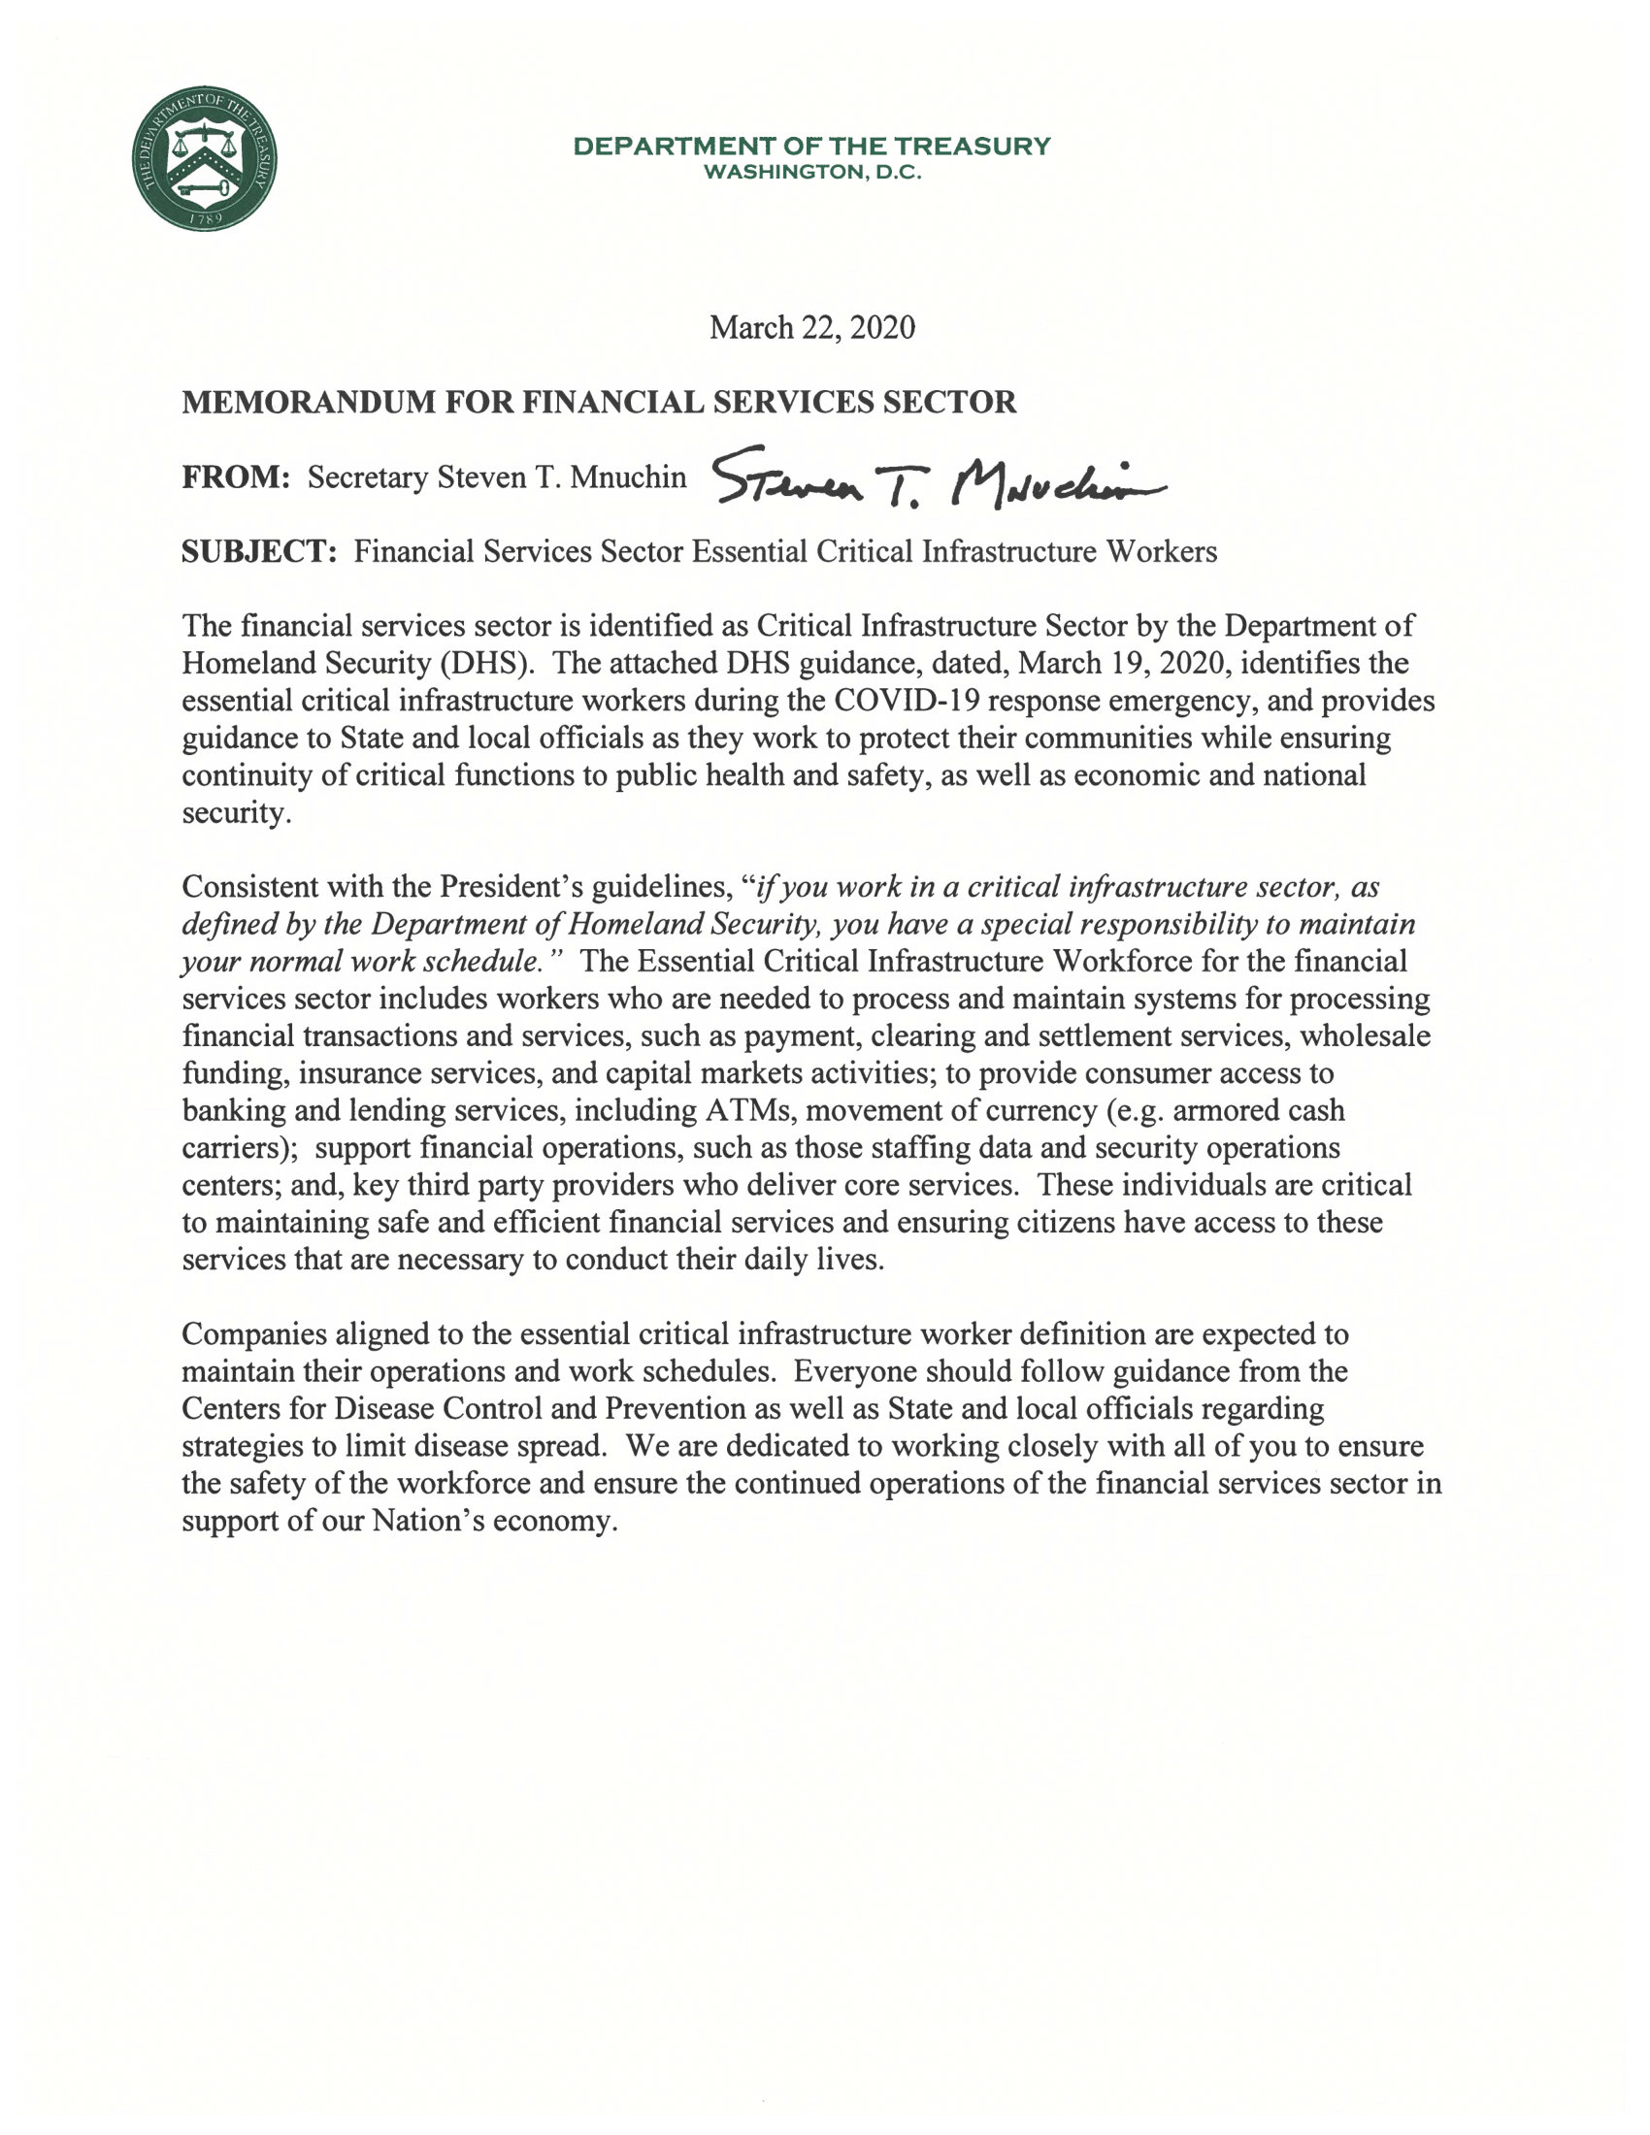

Statement by Secretary Steven T. Mnuchin on Essential Financial Services Workers

23
March 24, 2020

WASHINGTON—U.S. Treasury Secretary Steven T. Mnuchin issued the following statement on Financial Services Sector Essential Critical Infrastructure Workers:
“I strongly support the Department of Homeland Security’s recent guidance identifying financial services sector workers as essential critical infrastructure workers during the COVID-19 response emergency. The guidance provides information to State and local officials, as they work to protect their communities, to ensure the continuity of functions that are critical to public health and safety, as well as economic and national security. Consistent with the President’s guidelines, ‘if you work in a critical infrastructure sector, as defined by the Department of Homeland Security, you have a special responsibility to maintain your normal work schedule.’
“The financial services sector is identified as a Critical Infrastructure Sector by the Department of Homeland Security. The Essential Critical Infrastructure Workforce for the financial services sector includes workers who are needed to process (and maintain systems for processing) financial transactions and services, such as payment, clearing, and settlement services, wholesale funding, insurance services, and capital markets activities. Essential financial services workers provide consumer access to banking and lending services, including ATMs and the movement of currency (e.g., armored cash carriers). They support financial operations, including data and security operations centers. Essential workers also include key third-party providers who deliver core services.
“The American people need access to financial sector services, and State and local governments must ensure the continuity of critical financial sector functions. Everyone should follow guidance from the Centers for Disease Control and Prevention as well as State and local officials regarding strategies to limit disease spread. We are dedicated to working closely with the financial services sector to ensure the safety of the workforce and continuity of operations to support our Nation’s economy and all hardworking Americans.”
####

